|  |
| --- |
| **rmp software solutions** |
| **SIDE SCROLLER** |
| *Assignment 03* |
| Version 1  All work Copyright © 2015 by XX Games.  All rights reserved. |
| **RUKSHAR PATEL** |
|  |

|  |
| --- |
| July 10th 2015 |

Table of Contents

Version History 3

Game Overview 4

Game Play Mechanics 4

Controls 4

Interface Sketch 4

Menu and Screen Description 7

Character 7

Enemies 8

Scoring 8

Sound Index 8

Art/Multimedia Index 8

# Version History

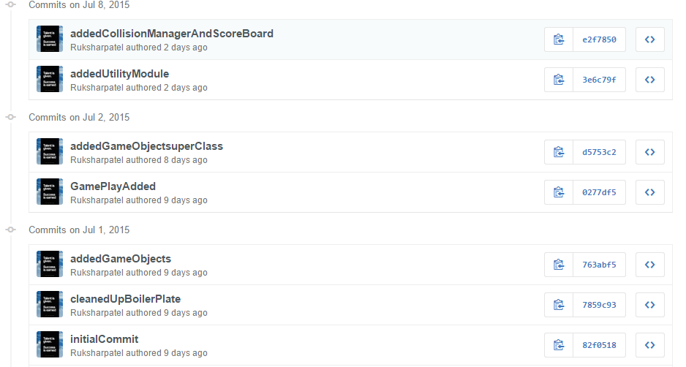

***Link to GitHub***: <https://github.com/Ruksharpatel/Assignment03>

### Game Overview

This Water coins game also known as side scroller, in which the player has to help the fish to collect the gold coins without colliding with the stars coming through the way. The player gets maximum five lives, and each time the fish collides with the star, the player loose his lives. It is a challenging game and there are chances of losing lives more and hit the maximum points.

### Game Play Mechanics

In this game, the player controller is the fish and its aim to collect gold coins as many as possible avoiding stars and achieve maximum points as possible.

### Controls

This game allows player to use only mouse to control the fish and saving it from the stars and to collect gold coins to move up and down towards the stage

### Interface Sketch

The interface of the game is similar to the real world games, starting from menu screen which includes the instructions for the player and a button to start the game, which after pressing start it takes him to the next play screen and finally, if the player loses all his 5 lives, it shows the last UI to the user which is called game over screen. It also includes the button control for the user to restart the game.

***SCREEN 01***

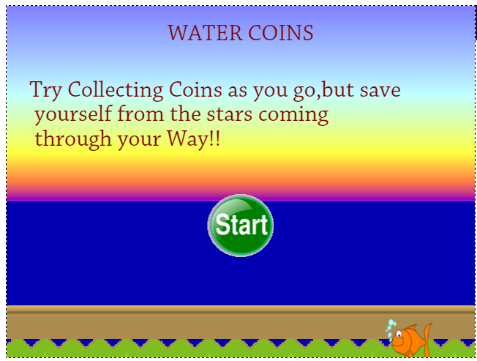

***SCREEN 02***

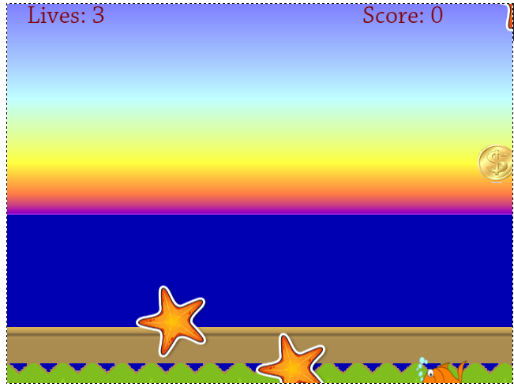

***SCREEN 03***

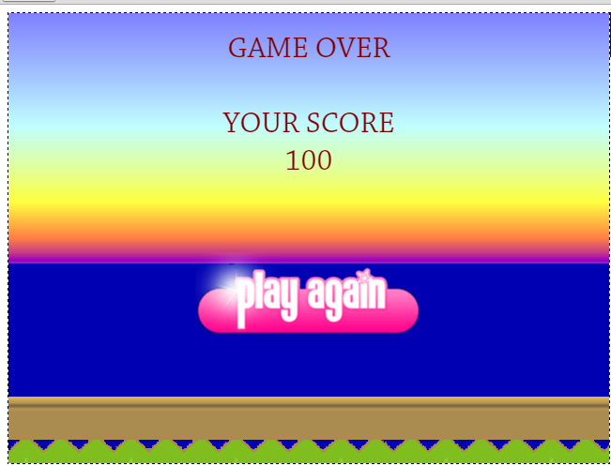

### Menu and Screen Description

The game have menu screen which is usually the user first interacts with. It shows player how to play the game. Also, 2 more screens for the player which is game screen and end screen which displays player final score. All 3 screens uses a parallax background which constantly updates after every time frame. Also, the game stats are recorded for every screen from the beginning till the end of the game.

### Character

This main character of the game is Fish under water which will be controlled by player to play the game. The player can scroll fish only up or down to collect gold coins and earn maximum points through out the game.

### Enemies

In this game, the enemy of the player are the stars which appears randomly and cause the player to lose their lives. Every time the player collides with the stars, he loose his one life. The minimum number of life given to the player is five.

### Scoring

The player can score as high as possible, depending upon the coins they collect. The player score increases by 100 when they pick the gold coin.

### Sound Index

This game has 3 different sounds namely coin.wav (when the user collects gold coins), hit.wav(when the player collides with star) and the background river (underwater.mp3)sound which is repeated in from the beginning of the game.

### Art/Multimedia Index

The game uses .png image for the transparency

The images of this game are: fish, river, coin and star

